AMISPEC WORKSHOP

4th workshop of all project partners - AMISPEC
(Advanced Microscopy and Spectroscopy Platform for Research and Development in Nano and Microtechnologies)

- When: 8. 3. 2016
- Where: ISI Congress Centre
Brno, Královopolská 147

Project Address: Faculty of Mechanical Engineering
Brno University of Technology
Brno, Technická 2896/2

Workshop programme:

9:00 – 9:40 Gareth S. Parkinson (Institute of Applied Physics, Technical University of Vienna):
Single–Atom Catalysis: An Atomic-Scale View

9:50 – 10:30 Jiří Homola (Institute of Photonics and Electronics, Czech Academy of Science Prague):
Plasmonic Biosensors and their Applications

10:40 – 11:20 Laurent Ranno (Institut Néel, CNRS, Université Joseph Fourier, Grenoble):

Antiferromagnetic behaviours in ferromagnetic structures

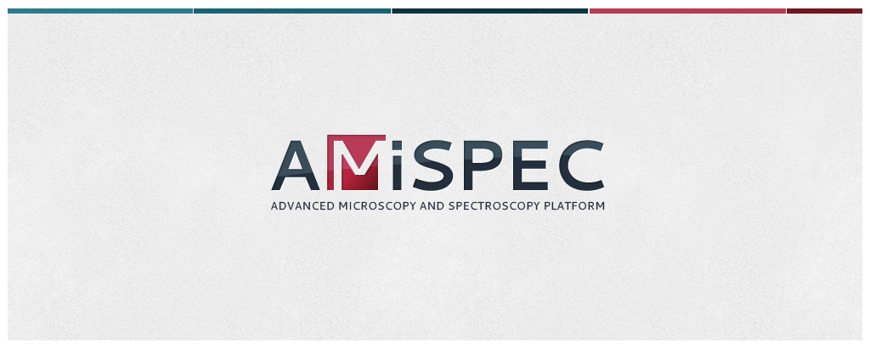

Contact person:
Oto Lipovský
Tel.:+420 733 472 851
e-mail: lipovsky@fme.vutbr.cz



